New Signage Request for Proposal for
First Church of Christ, Scientist, Athens, GA
578 Whitehead Road
Athens, GA 30606
678-371-9373/jkimbb@msn.com (Kimberley Hancock, on behalf of FCCS, Athens)
www.ChristianScienceAthens.com

The Two Quotes Needed
- Quote for the sign as outlined below, see Images C (below) for desirable options
- Quote for a cheaper sign option like Image D (below)
Quote 1 :: This sign…
- Needs to be quite larger than current sign – both in height and width, and look the same from both sides. As large as it can be, without protruding into the sidewalk, and without becoming unstable. See Images B below for current signage.
- Needs to be well lit at night (externally lit). The current lights are inoperable – we suspect one of the internet service providers cut the power line when digging/replacing their own line.
- What kind of city/county sign approval will we need? Can you (the sign maker) get that approval for us?
- Should include the following elements:
  - Cross and Crown (we will pay the $250 and get approval from TMC for the legal use of the trademark), see Image A below.
  - With the C&C, we don’t need Bible quotes (they’re included); so C&C needs to be large
- Should include the following text:
  - FIRST CHURCH OF CHRIST, SCIENTIST
    - (All caps, with first letters of each word being larger capital letters)
  - Cross and Crown (see Image A)
  - www.ChristianScienceAthens.com
  - SUNDAY SERVICES and SUNDAY SCHOOL
    - Hanger 5
    - Hangers 6 (used one at a time)
  - WEDNESDAY MEETING
    - Hanger #3
  - READING ROOM
    - Hanger #1 here
  - [space for 1 additional hanger]
- Hangers should be able to be missing, without undue confusion.
- Space for four hangers.
- Must have two copies of every hanger – front and back
  - Hanger 1
    - Come for Spiritual Discovery and Refreshment
    - Tuesdays and Thursdays 11-2
  - Hanger 2
    - Thanksgiving Day Service 10:30 – 11:30 am
    - All are welcome!
  - Hanger 3
    - Come as you are!
    - 7:30 pm in the Sunday School (entry in back)
  - Hanger 4
    - [Custom – content to be provided later] for lectures, special public meetings, Bible quotes, etc.
  - Hangers 5
    - Sunday mornings at 10:30 am
  - Hangers 6 – used one at a time
    - The subject this Sunday is:
God
    - The subject this Sunday is:
Sacrament
    - The subject this Sunday is:
Life
    - “”
Truth
    - “”
Love
    - “”
Spirit
    - “”
Soul
    - “”
Mind
    - “”
Christ Jesus
    - “”
Man
    - “”
Substance
    - “”
Matter
    - “”
Doctrine of Atonement
    - “”
Adam and Fallen Man
    - “”
Mortals and Immortals
    - “”
Soul and Body
    - “”
Ancient and Modern Necromancy, alias Mesmerism and Hypnotism, Denounced
    - “”
God the Only Cause and Creator
    - “”
God the Preserver of Man
    - “”
Is the Universe, Including Man, Evolved by Atomic Force?
    - “”
Christian Science

Image A – Cross and Crown (trademarked)

Images B – Current signage (disregard Shawn and the bar he’s holding, but he gives a good idea of the current size)
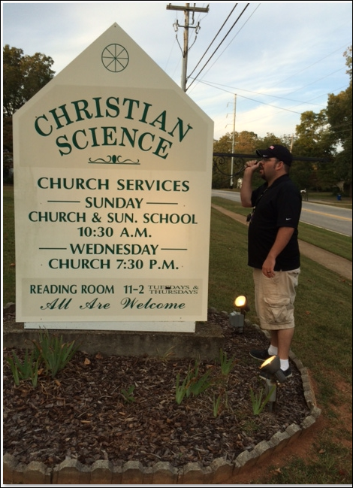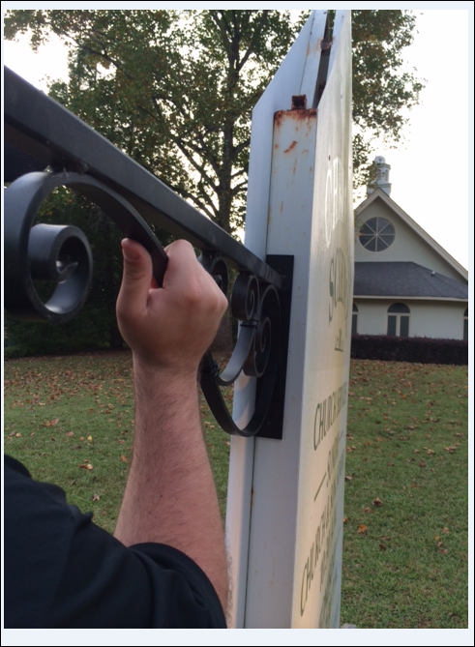

Images C - My Favorite sign styles in descending order of how much I like them (size of emblem, though the service start times are very hard to read):
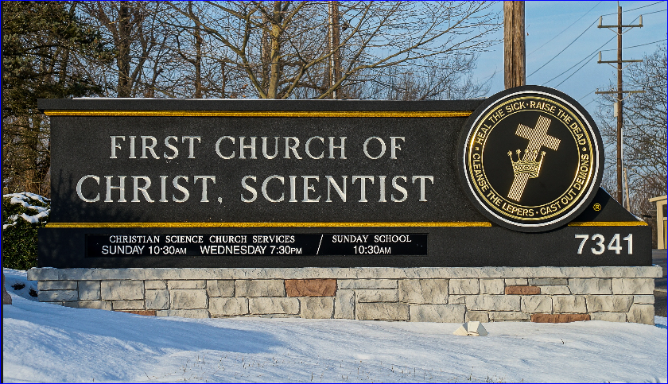
If you add an extra row or spaces below the bottom gold line, you could have a spot for all requested hangers.
2nd Church Atlanta
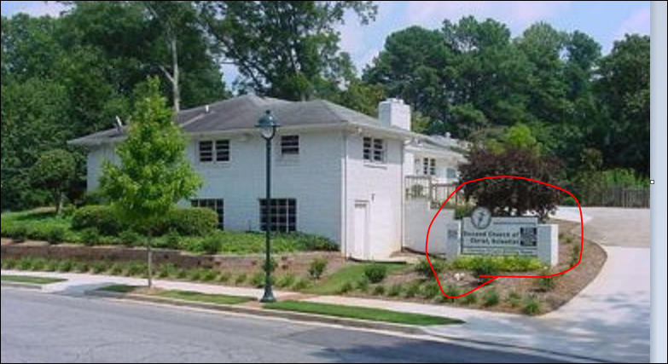
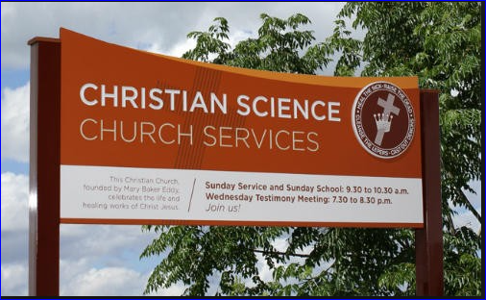
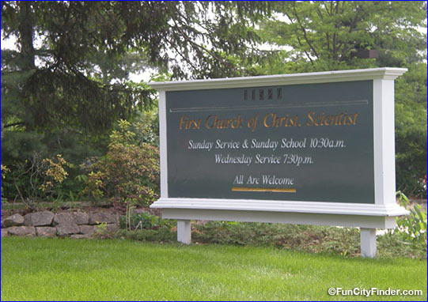
Images D - Cheaper Signs, in order of desirability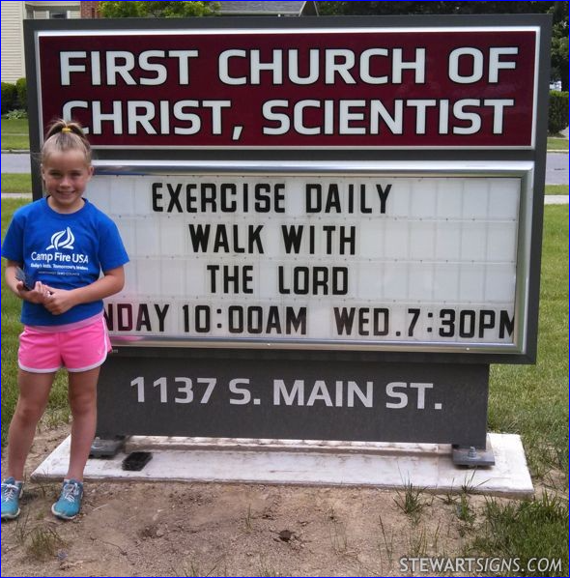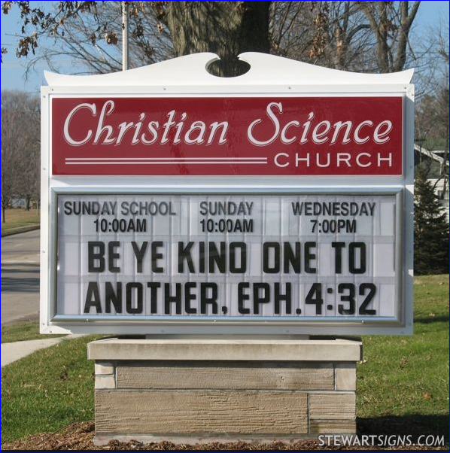

Images E – Other Sign Samples

